REPORT

SOCIAL MEDIA ENGAGEMENT

*Submitted by*

**Nelson Joseph**

**29 MAY 2023**

Table of Contents

Introduction 3

Data Description 4

Data Pre-processing 4

Visualization of each columns subcategories vs data count 4

Analysis on Dataset for Engagement Rate 5

Analysis on Day of the Week 6

Analysis on Peak time of Each day of Week 7

Analysis on Campaign Type 8

Task 9

What is the typical engagement rate we can expect? What’s the likelihood that we can achieve a 15% engagement rate? 9

Does day of the week and time of posting affect engagement rates? 10

How are our game titles doing in terms of social performance? Is there a specific game we should focus more on or less? 11

What media type performs the best? 11

What is our best performing campaign? 13

Define out a posting strategy for our social channels based on your discoveries. 14

Conclusion 15

# Introduction

The engagement rates of various post formats, including text, links, images, and videos, across multiple social media platforms were analyzed in this paper. The data was pre-processed to prepare it for analysis before being used in the analysis. To compare the engagement rates of various platforms, the data was then divided into subcategories. In particular, the engagement rates of well-known games like CSGO, DOTA 2, and Valorant on websites like YouTube, LinkedIn, Facebook, and twitter were examined.

The analysis involves a careful assessment of the data, and the conclusions are explained in great depth in the pages that follow. The findings in this study seek to offer insightful data on the engagement rates of various post kinds.

# Data Description

The dataset contains information about the different games and their related posts that are posted in different platforms that include Facebook, YouTube, LinkedIn, twitter, Instagram and TikTok. The contents are posted in different forms to increase the engagement of the games. The main participants are CSGO, DOTA2, General, Valorant etc.

## Data Pre-processing

There were several pre-processing steps done with the dataset. Some of them are: -

* The ‘Published Date’ Column contained date as well as time which was separated into dates and time and eventually to hour and day for evaluation of importance of day in a week and importance of timings per day for posting some content.
* There were two sets of General, one as ‘General’ and ‘General ‘which was combined to improve accuracy of our findings.
* Several functions were written to plot different forms of data that are grouped together.

## A picture containing text, screenshot, diagram, plot Description automatically generatedVisualization of each columns subcategories vs data count

# Analysis on Dataset for Engagement Rate

The data was grouped based on Account and Account type, media type to check the Engagement rates.

## A picture containing text, screenshot, colorfulness, diagram Description automatically generatedAnalysis on Day of the Week

## Analysis on Peak time of Each day of Week

**Peak Hours of Monday**

Hour Engagement Rate

0 10 12.0

1 13 11.9

2 9 10.8

**Peak Hours of Tuesday**

Hour Engagement Rate

0 5 51.8

1 16 16.3

2 17 15.1

**Peak Hours of Wednesday**

Hour Engagement Rate

0 7 21.5

1 5 15.2

2 14 13.4

**Peak Hours of Thursday**

Hour Engagement Rate

0 21 21.6

1 7 20.9

2 8 16.1

**Peak Hours of Friday**

Hour Engagement Rate

0 18 16.9

1 4 15.2

2 10 11.4

**Peak Hours of Saturday**

Hour Engagement Rate

0 9 12.7

1 3 10.0

2 8 9.8

**Peak Hours of Sunday**

Hour Engagement Rate

0 20 29.9

1 8 21.4

2 17 19.2

## Analysis on Campaign Type

Most of the data in the dataset were not part of any campaign. The Community Engagement performed well in increasing the engagement rates than Evil Exhibited and Evergreen. We cannot validate the findings since different amounts of data is used for comparison here.

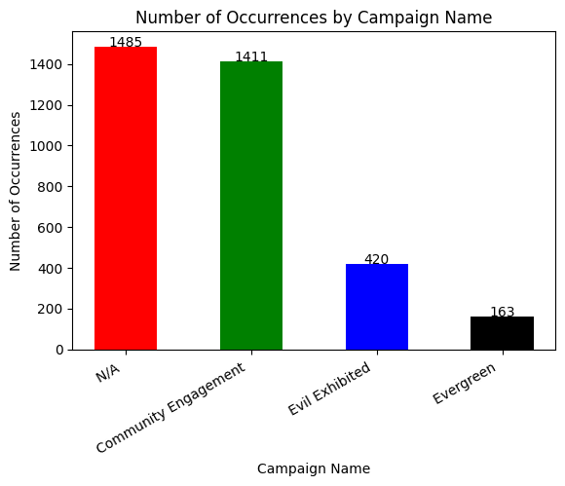

# Task

## What is the typical engagement rate we can expect? What’s the likelihood that we can achieve a 15% engagement rate?

The typical engagement rate on social media can vary depending on the platform, industry, and the types of audience. However, a good benchmark for engagement rate is around 1-5% for most social media platforms.

Based on the analysis results, it is possible to achieve an engagement rate of 15%, but it is important to note that this may result in fewer impressions. Typically, when content is initially posted, it will have a higher engagement rate from the impressions it receives. However, as time goes on, the gap between impressions and engagements may increase.

To achieve a 15% engagement rate, a highly engaged and dedicated audience is necessary, along with a well-crafted social media strategy. It is important to keep in mind that engagement rate is just one aspect of social media success, and it is crucial to focus on creating valuable content, building relationships with your audience, and measuring the overall impact of your social media efforts. By doing so, you can maximize the impact of your social media presence and achieve your desired goals.

## Does day of the week and time of posting affect engagement rates?

Yes, day of the week in which the content is posted have a high importance on its engagement. But it depends more on what type of content is posted on what time. The main idea behind it is that if we posting a content related to coffee-on-coffee time the chance of engagement is more than posting the same content on lunch time.

The best day and time to post on social media can vary depending on the platform, industry, and audience. From the analysis I found that: -

* **Sunday** is the best day to post on Facebook which showed maximum engagement rate.
* **Saturday** for YouTube and followed by **Friday**. For YouTube the impressions were less compared to other platforms, but it had more engagements out of it.
* In case of Twitter the best engagement rate was shown on **Wednesday** and **Tuesdays**.
* For TikTok as well it was **Tuesday** getting best engagement rate.
* In case of Instagram the engagement rates were comparatively lesser it is of the range of **2.5 – 3** and the best day **Wednesday** as per analysis.
* For LinkedIn it was showing the **Friday** as the day which generates maximum engagement.

In Case of Peak timings, it is found that: -

* **Monday –** The timing between **9am** and **1pm** generated the best Engagements rates.
* **Tuesday –** It was between 4pm to 5pm.
* **Wednesday –** It was 5 am, 7 am and 2pm
* **Thursday –** It was 7am, 8 am and 9 pm
* **Friday -** It was 10am and 6pm
* **Saturday –** It was between 8am – 9am
* **Sunday –** It is between 5 pm – 8 pm

## How are our game titles doing in terms of social performance? Is there a specific game we should focus more on or less?

* **CSGO** is performing best in **Twitter**. It showed a engagement rate of **5.2** for the **Twitter videos.**
* For **Content Creators** the **YouTube** is the best platforms that allows them to get a good engagement rate on videos.
* For **DOTA2**, among different media types published in twitter and YouTube, **Twitter videos** performed more Engagement rates than YouTube.
* For **General**, which was published on all platforms, The order of Engagement rates are as follows. **Facebook page, Twitter, TikTok business, Instagram, YouTube, and finally LinkedIn**.
* Finally, the **Valorant**, which was published only on YouTube. The **YouTube videos** generated a good engagement rate of **4.1**.

## What media type performs the best?

Among all the data in the dataset the photos were used maximum on the social media.

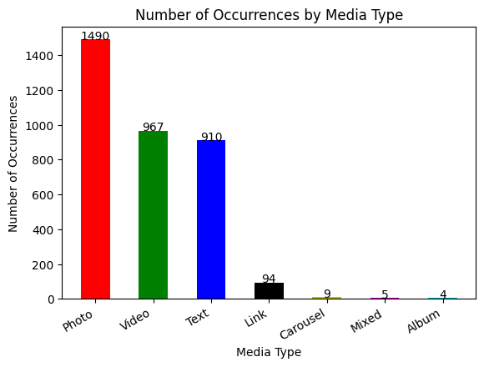

For **Twitter** the Video showed the highest engagement rate.

* For **Content Creators** it was **YouTube video** with an Engagement rate of 3.1
* For **Valorant** too it was **YouTube video** with an Engagement rate of 4.1
* For **DOTA2**, Among the platform **twitter** and **YouTube**, in twitter the **mixed** **media** type performed well, and **YouTube videos** showed an engagement rate of **6.7**.
* A picture containing text, screenshot, diagram, plot

  Description automatically generated
* In Case of General, **Facebook album** showed a very high engagement rate, but the engagements were only compared out of the less than 100 impressions it cannot be considered a valid value. **Facebook photos, Ticktock business video, Mixed twitter** posts also showed a good engagement rate.
* A picture containing text, screenshot, diagram, plot

  Description automatically generated

## What is our best performing campaign?

Most of the data in the dataset were not part of any campaign. The Community Engagement performed well in increasing the engagement rates than Evil Exhibited and Evergreen. Community Engagement is best performing campaign with respect to the Engagement rates. The Eva green and Evil Exhibited are showing similar performance.

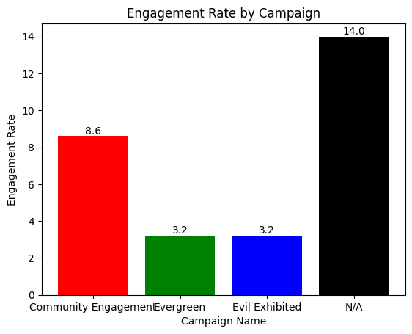

## Define out a posting strategy for our social channels based on your discoveries.

There is a huge opportunity for improvement and engagement by properly using the platform. There is Major posting strategies we can adopt are: -

1. **Posting during Peak timings**

From the previous analysis on best days of the week for different platforms and peak timings in each day one can find the optimal time and day for posting contents in each of the platforms.

1. **Posting Consistently**

This increases the engagement but remember not to lose the quality of the content otherwise it can lead to bad impressions as well.

1. **Experimenting with different contents.**

Some of the games were having contents of only videos. The mixed content on Twitter performed well. So, trying out new types of contents will be having better engagement.

## What suggestions would you give to the social media team if they want to expand their presence (e.g., if our CSGO YouTube channel is doing well should we expand to TikTok)?

From the Analysis it is understandable that there are platforms that provide good engagement on contents that are not being used properly.

1. **Experimenting with different content types**: The Social media team should focus on creating more videos and photo contents that can be posted in Twitter, Instagram and Facebook which provides good engagements. The texts and links related contents have more engagement in twitter than other platforms. So, the social media team can focus only posting contents related to text and links more on twitter and LinkedIn than Instagram and Facebook.
2. **Engaging with the communities**: The social media is a two-way conversation, and it is important to engage on community on the new platforms. The gaming accounts can create community in twitter and LinkedIn where text-based contents have good engagement rates.
3. **Leveraging existing Conte**nt: The CSGO YouTube channel is having good engagement rates with the videos. The same videos can be made cut shorted to make short ticktock videos which provides good engagement rate on videos. Similarly, for DOTA2 and Valorant.
4. **Use of structure as a promotion environment**: The Accounts can create communities in platforms like twitter and LinkedIn. This can be used as means to provide their contents in different platforms as well as the contents in same platform.

# Conclusion

In conclusion, the analysis of social media performance for the gaming industry has provided valuable insights into the engagement rates of different platforms, media types, and posting strategies. The typical engagement rate on social media varies depending on the platform, industry, and audience, but a good benchmark is around 1-5%. The day of the week and time of posting have a significant impact on engagement rates, and it is important to experiment with different content types and engage with the community to expand the social media presence.

The best performing campaign was found to be Community Engagement, and CSGO was the best performing game title on Twitter. The media type that performed the best was photos, and videos showed the highest engagement rate on Twitter.

Based on the analysis, the social media team can focus on creating more videos and photo contents, experimenting with different content types, engaging with the community, leveraging existing content, and using the structure as a promotion environment to expand their social media presence. By implementing these strategies, the team can maximize the impact of their social media presence and achieve their desired goals.